# Opioid Letter Samples Related to UM (Utilization Management) Program

Opioid Update to MME (Morphine Milligram Equivalents)

Opioid Member Letter MME (Morphine Milligram Equivalents) with PA (Prior Authorization) (7335-53925A)

Opioid Member Letter MME (Morphine Milligram Equivalents) Post Limit (7335-53925C)

Opioid Prescriber Letter (7335-53925G)

NY Exchange Opioid Prescriber Letter (58666A)

NY Exchange Opioid Member Letter MME (Morphine Milligram Equivalents) Post Limit (58666B)

NY Exchange Opioid Member Letter MME (Morphine Milligram Equivalents) with PA (Prior Authorization) (58666C)

Related Documents

**Description:** Provides illustrations of letters sent to members and prescribers for this program.

|  |
| --- |
| Opioid Update to MME (Morphine Milligram Equivalents) |

Effective July 1, 2023, CVS Caremark will update morphine milligram equivalency (MME) calculations consistent with the recently updated Centers for Disease Control and Prevention (CDC) opioid prescribing guideline. Drug Utilization Review (DUR) and Utilization Management (UM) Quantity Limit (QL) updates will occur for certain medications.

Members who are prescribed quantities greater than the updated initial QLs listed above may require a prior authorization (PA) at their next fill – even if they have a history of receiving the prescription at that dosage. For members who exceed the updated post limits, an appeals process is available.

**CCR Action:** If you receive a call regarding one of the letters in this document, review the letter with the caller and if they need more information, warm transfer the call to Clinical Care services.

Top of the Document

|  |
| --- |
| Opioid Member Letter MME (Morphine Milligram Equivalents) with PA (Prior Authorization) (7335-53925A) |

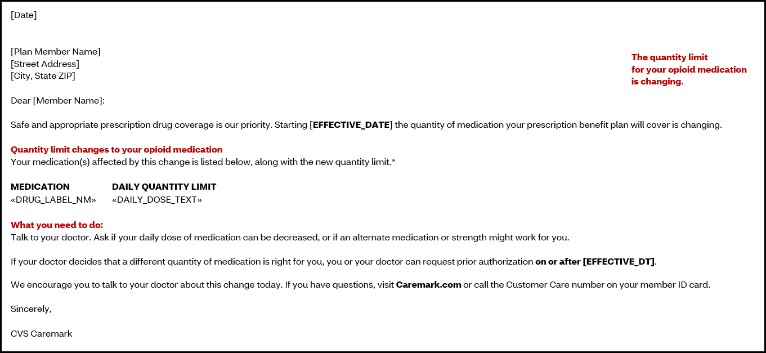

Top of the Document

|  |
| --- |
| Opioid Member Letter MME (Morphine Milligram Equivalents) Post Limit (7335-53925C) |

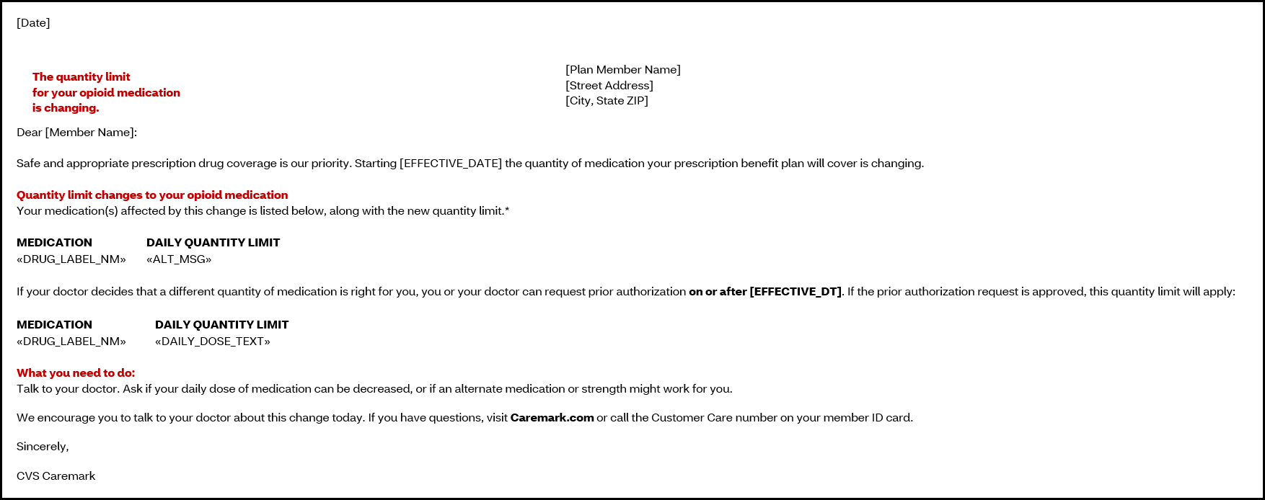

Top of the Document

|  |
| --- |
| Opioid Prescriber Letter (7335-53925G) |

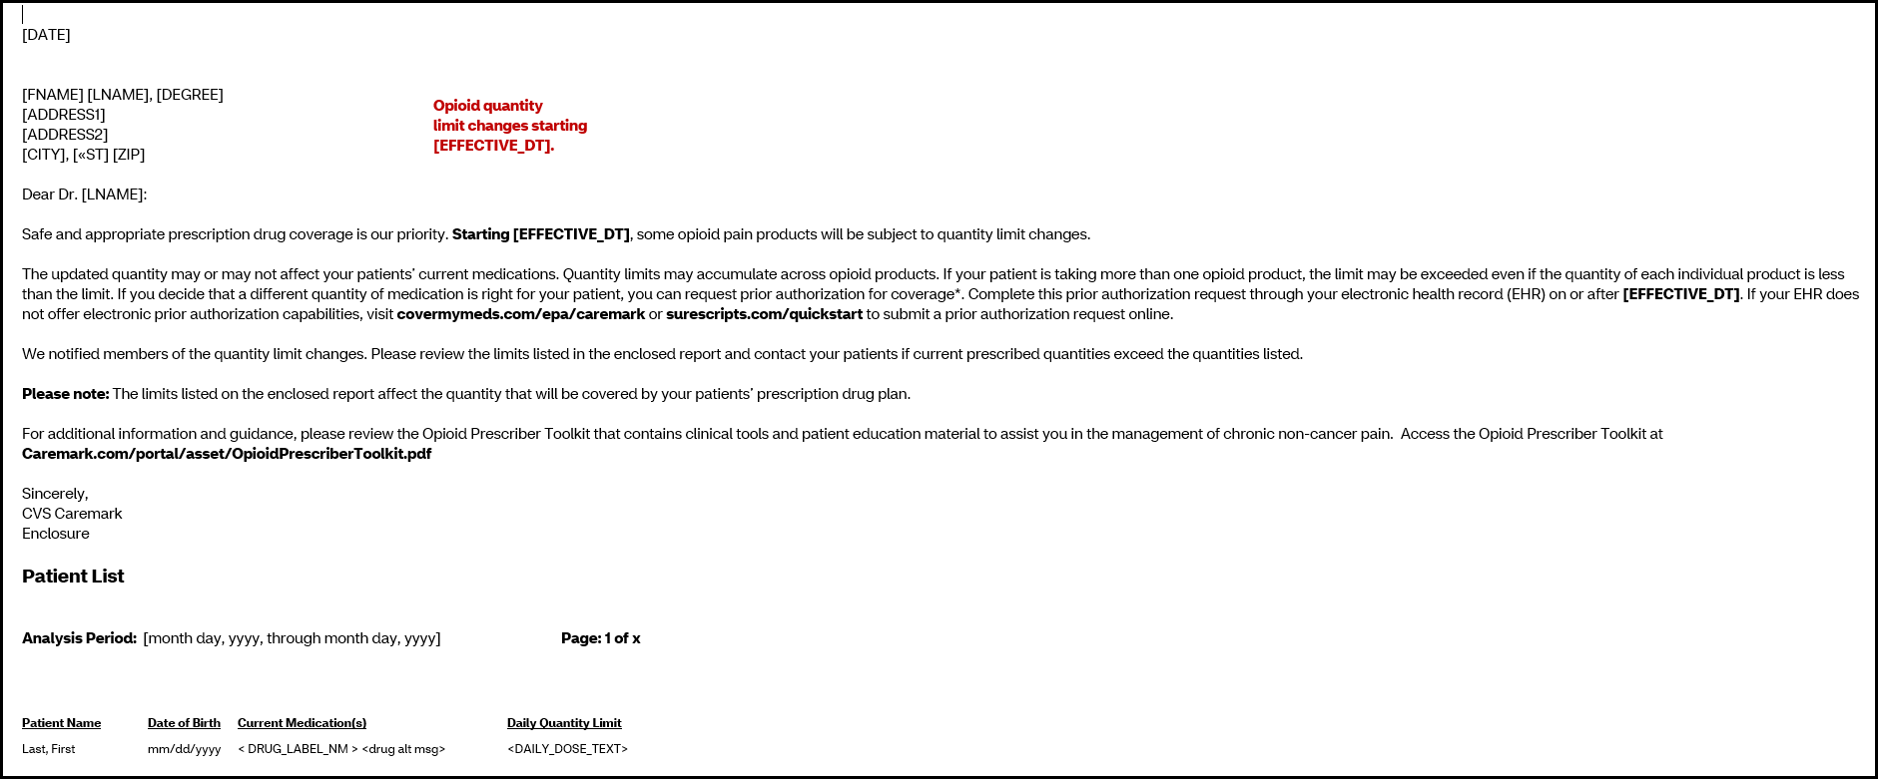

Top of the Document

|  |
| --- |
| NY Exchange Opioid Prescriber Letter (58666A) |

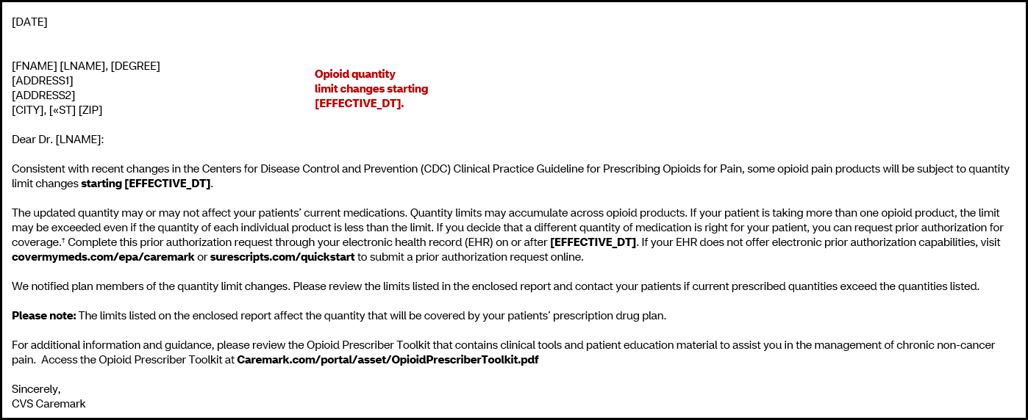

Top of the Document

|  |
| --- |
| NY Exchange Opioid Member Letter MME (Morphine Milligram Equivalents) Post Limit (58666B) |

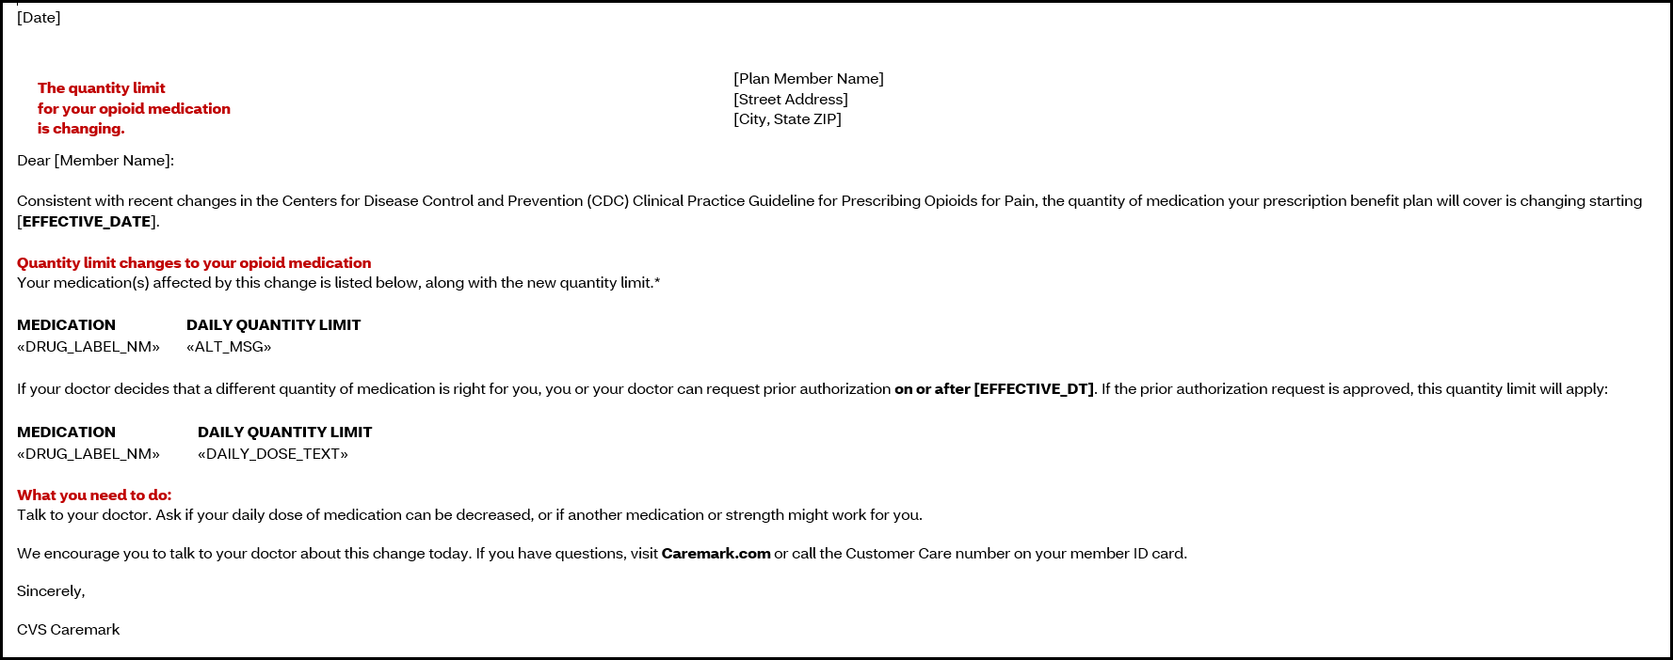

Top of the Document

|  |
| --- |
| NY Exchange Opioid Member Letter MME (Morphine Milligram Equivalents) with PA (Prior Authorization) (58666C) |

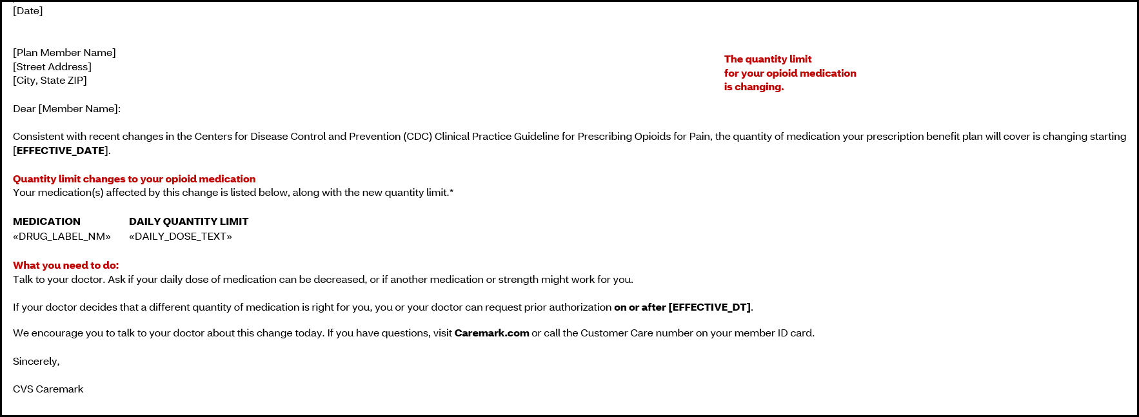

Top of the Document

|  |
| --- |
| Related Documents |

[[Customer Care Abbreviations/Definitions and Terms Index](https://thesource.cvshealth.com/nuxeo/thesource/#!/view?docid=c1f1028b-e42c-4b4f-a4cf-cc0b42c91606)](https://thesource.cvshealth.com/nuxeo/thesource/#!/view?docid=c1f1028b-e42c-4b4f-a4cf-cc0b42c91606) (017428)

Top of the Document

Not To Be Reproduced or Disclosed to Others Without Prior Written Approval

**ELECTRONIC DATA = OFFICIAL VERSION / PAPER COPY = INFORMATIONAL ONLY**